TABLE OF CONTENTS:

1. BRIEF DESCRIPTION: 3
2. BLOCK DIAGRAM: 3
3. WORKING: 3
4. CIRCUIT DIAGRAM: 3
5. Component Map: 4
6. HARDWARE: 4
7. SOFTWARE: 4

LIST OF FIGURES:
Figure 1: BLOCK DIAGRAM 3
Figure 2: CIRCUIT DIAGRAM 3

LIST OF TABLES:
Table 1: Component List 5

HOME SECURITY SYSTEM USING GSM:

Document Created By: Ali Raza.
Document Creation Date:07 Aug ‘10
Update History:
Updated on | Updated By | Sections Updated

HOME SECURITY SYSTEM USING GSM:

1. BRIEF DESCRIPTION:
The objective of this project is to design & develop a circuit by which security of the home can be assured.

2. BLOCK DIAGRAM:
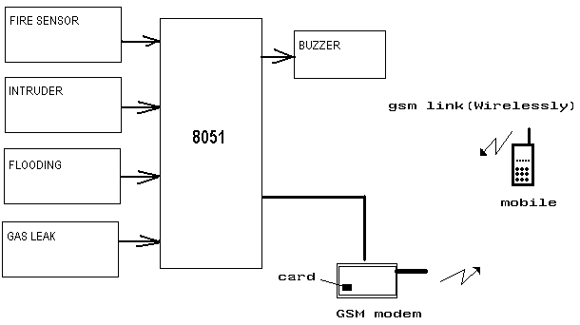
Figure 1: BLOCK DIAGRAM

3. WORKING:
In this project different sensors will be used along with µC. IR Tx & Rx will be used to detect intruder. LPG sensor will be used to detect the gas leak as well as smoke. Probes will be used to detect the flooding situation.
GSM modem will be interfaced with µC. Whenever any of the following situation arise like
UNAUTHORISED ENTRY/BREAK IN/INTRUDER
GAS LEAK
SMOKE/FIRE
FLOOD
Then buzzer will turn ON & at the same time sms will be sent to the house owner’s mobile.

4. CIRCUIT DIAGRAM:

Figure 2: CIRCUIT DIAGRAM

5. Component Map:
COMPONENT INSTANCE | COMPONENT TYPE | COMPONENT VALE | NO. | COST.
Table 1: Component List

6. HARDWARE:
- AT89C51 microcontroller
- IR.
- MAX 232 for level (protocol) conversion
- LPG sensor

7. SOFTWARE:
- Kiel uv3 for Embedded ‘C’
- Flash magic for code downloading

